The Project Objective

In this final project, we will be seeing (and hearing) how our body uses electricity to communicate. The first step to doing this is to sense the electrical activity. Electrodes are electrical conductors that sense ion distributions on tissue and convert that ion current into an electrical current. For this project, we will pick a noninvasive option for sensing bioelectrical signals by using body surface electrodes to detect the electrical activity that occurs when a muscle contracts.

This electrical activity is in the microvolts range and not detectable directly by our lab instruments. So we will need to amplify and filter the signal, and create appropriate interfacing that will allow us to both visualize and hear the signal, and give us some interesting information about it.

Muscle Bioelectrical Signals

When you decide to move a muscle, upper motor neurons from your motor cortex travel to your spinal cord where they synapse with lower motor neurons. These lower motor neurons synapse with multiple muscle fibers to form a motor unit. Each muscle fiber is made up of actin/myosin chains that slide across each other when there is a specific voltage potential, changing the muscle fiber shape.

When a motor neuron fires an electrical impulse creating an action potential, acetylcholine is released at the synapse, or the neuromuscular junction, causing a change in the electrical potential of the muscle. This causes voltage-gated calcium channels to open and propagate the action potential across the muscle cells, creating a muscle contraction.

The action potentials that occur in the muscle can be sensed by body surface electrodes. We will build an instrument called an electromyogram (EMG) that will amplify and process this signal into a detectable and informative signal.

EMG System

The EMG block diagram will look like this:

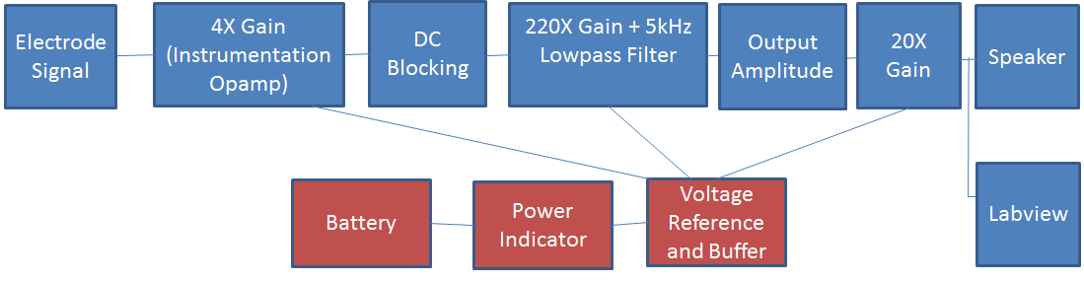

As you can see, there are multiple amplification stages of the signal sensed by the electrodes, along with other blocks that alter the signal. Each is described below:

4X Gain Instrumentation Amplifier: Instrumentation amplifiers are used commonly in measurement and test equipment, for which the impedance is unknown. Instrumentation amps have inbuilt input buffer amplifiers so no input impedance matching is required. These amplifiers reject noise and are used when accuracy is required. We will use an AD623N instrumentation amplifier.

DC Blocking: Any amplification stage will amplify both the ac and dc signal. Since we are interested in the microvolt ac signal of the action potentials, we will block the amplified dc voltage with a large value capacitor.

220X Gain+5kHz Lowpass Filter: This is the major gain stage of our EMG. This amplification stage will be done using a TLC2272 precision amplifier, wired as a differential amplifier. This IC has two op amps within it so we will use one for this stage and the other for the voltage reference circuit. The TLC2272 op amp can be wired to provide both gain and lowpass filtering. Although the significant range of EMG signal is around 5-500 Hz, we will design a lowpass filter to have a bandwidth of 5kHz for now.

Output Amplitude: The amplified dc term will need to be filtered out again with a big capacitor. Secondly, we can adjust the amplitude of the signal with a potentiometer that will eventually control the volume out of our speaker in the next stage.

20X Gain: The speaker requires a special amplifier called a LM386 which is an audio power amplifier. This op amp amplifies low power electronic signals to a level strong enough for driving high power speakers.

Battery: A 9-V battery will be used.

Power Indicator: We can test whether our circuit is being powered by placing an LED in parallel with the battery. The LED will light up when current is being drawn from the battery.

Voltage reference and buffer: The 220X gain amplifier requires a voltage reference signal equal to Vdd/2 when we use it as a differential amplifier. To create this voltage Vdd/2 we can use the second opamp in the TLC2272 IC as a voltage buffer to create this voltage. Using an opamp instead of a voltage divider allows us to create the desired voltage without the output (diff amp) loading the input (Vdd/2 reference).

Speaker: We will use the speakers from previous labs to hear the muscle activity we are sensing.

Labview: We will feed the bioelectrical signal to Labview to view what it looks like and analyze its frequencies, using some of the techniques learned this semester such as FFT.

Procedure

This is a nearly complete schematic of our EMG:

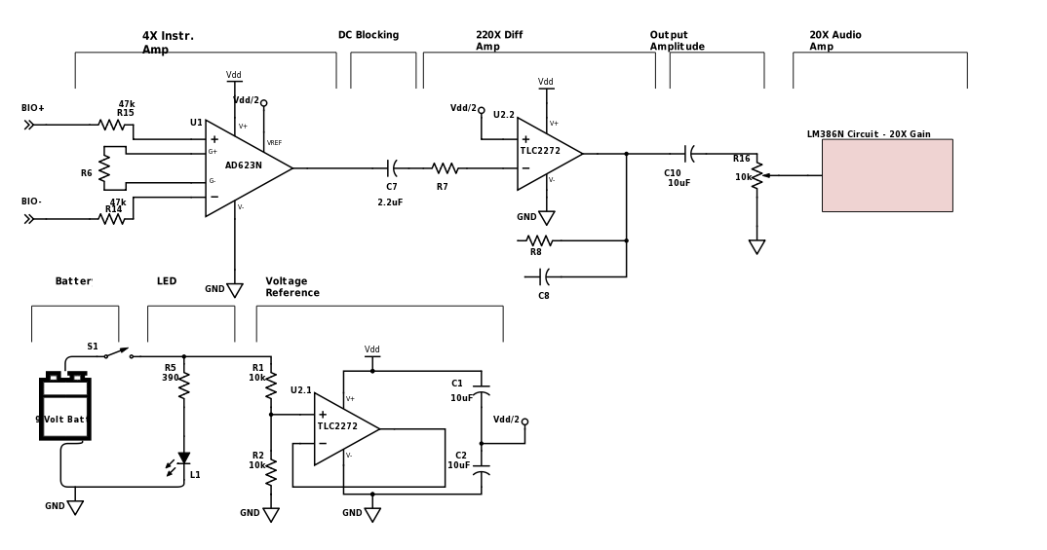

Build up your circuit on your breadboard following the schematic shown above. You will need to refer to the following datasheets to calculate some component values, understand pinouts, and build some of the system blocks:

<http://www.analog.com/media/en/technical-documentation/data-sheets/AD623.pdf>

<http://www.ti.com/lit/ds/symlink/tlc2272.pdf>

<http://www.ti.com/lit/ds/symlink/lm386.pdf>

The Labview interface can be as detailed as you like but the minimum requirements are:

1. User-friendly look
2. Time-domain waveform with averaging capability (for smoother waveform)
3. Voltage threshold indication
4. Frequency-domain waveform with information on what frequencies are being seen
5. Additional filtering ability (500Hz LPF)

Final Report and Demo

After you have created your working EMG, write up a lab report (in the same format as previous lab reports) and submit one final report per lab group.

You will also schedule a 5-min demo for the last week of classes. Walk us through the design, the Labview interface, any problems you encountered, and be ready to answer a few questions about your project.