Equipment

Test board

741 Op Amp

100&#8486; Resistor

10k&#8486; Resistors (2)

100k&#8486; Resistor

As we saw in the previous experiment, the op-amp isn't very useful in an "open-loop" configuration (i.e. without feedback). The most common configuration for op-amp circuits is the *inverting amplifier* where the output is an amplified and inverted version of the input (i.e. G is negative).

Part A: The Basic Inverting Amplifier

* Wire the following circuit using 10 k&#8486; resistors for both R1 and RF.   
    
  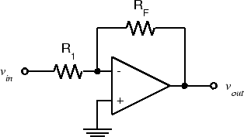
* Set the function generator to produce a 1 V p-p, 100 Hz sine wave. Measure the voltage gain, Gv=Vout/Vin. Since 100 Hz is within the frequency range of the DMM, you could use either the DMM or the scope to measure Vout and Vin. However, you should always use the scope to *view* the waveform being measured to make sure it is what you think it is. We will see several waveforms in this lab that aren't.
* Note that the output is inverted with respect to the input. **Take a screenshot for your report.**
* Replace RF with a 100 k&#8486; resistor. **Measure the gain.**
* Increase the input amplitude until output clipping occurs. **What is the clipping level? Is it the same as in Exp. 4.1?**
* Reduce the input amplitude until the output is 20 V p-p.
* Increase the frequency until the output amplitude drops to 10 V p-p**. You should see a triangular output waveform**. This is because there is a limit to the maximum rate at which the output voltage can change, called the *slew rate.* **Set the input to triangle and square wave and see how the output changes.**
* Reset the function generator for a 100 Hz sine wave and reduce the amplitude to produce a 1 V p-p output. Again increase the frequency until the output is 0.7 V p-p. **At what frequency does this occur?** Observe that the output is still sinusoidal. This is the actual cutoff frequency or *bandwidth* of the amplifier.