Equipment

Test board

LM741 (4x)

Resistors according to your design

Capacitors according to your design

Part A: Build a Function Generator

In this lab experiment, we will be building our own function generator using two new types of op amp circuits.

* Wire up the following RC relaxation oscillator circuit (see Introduction to read about its functionality):   
  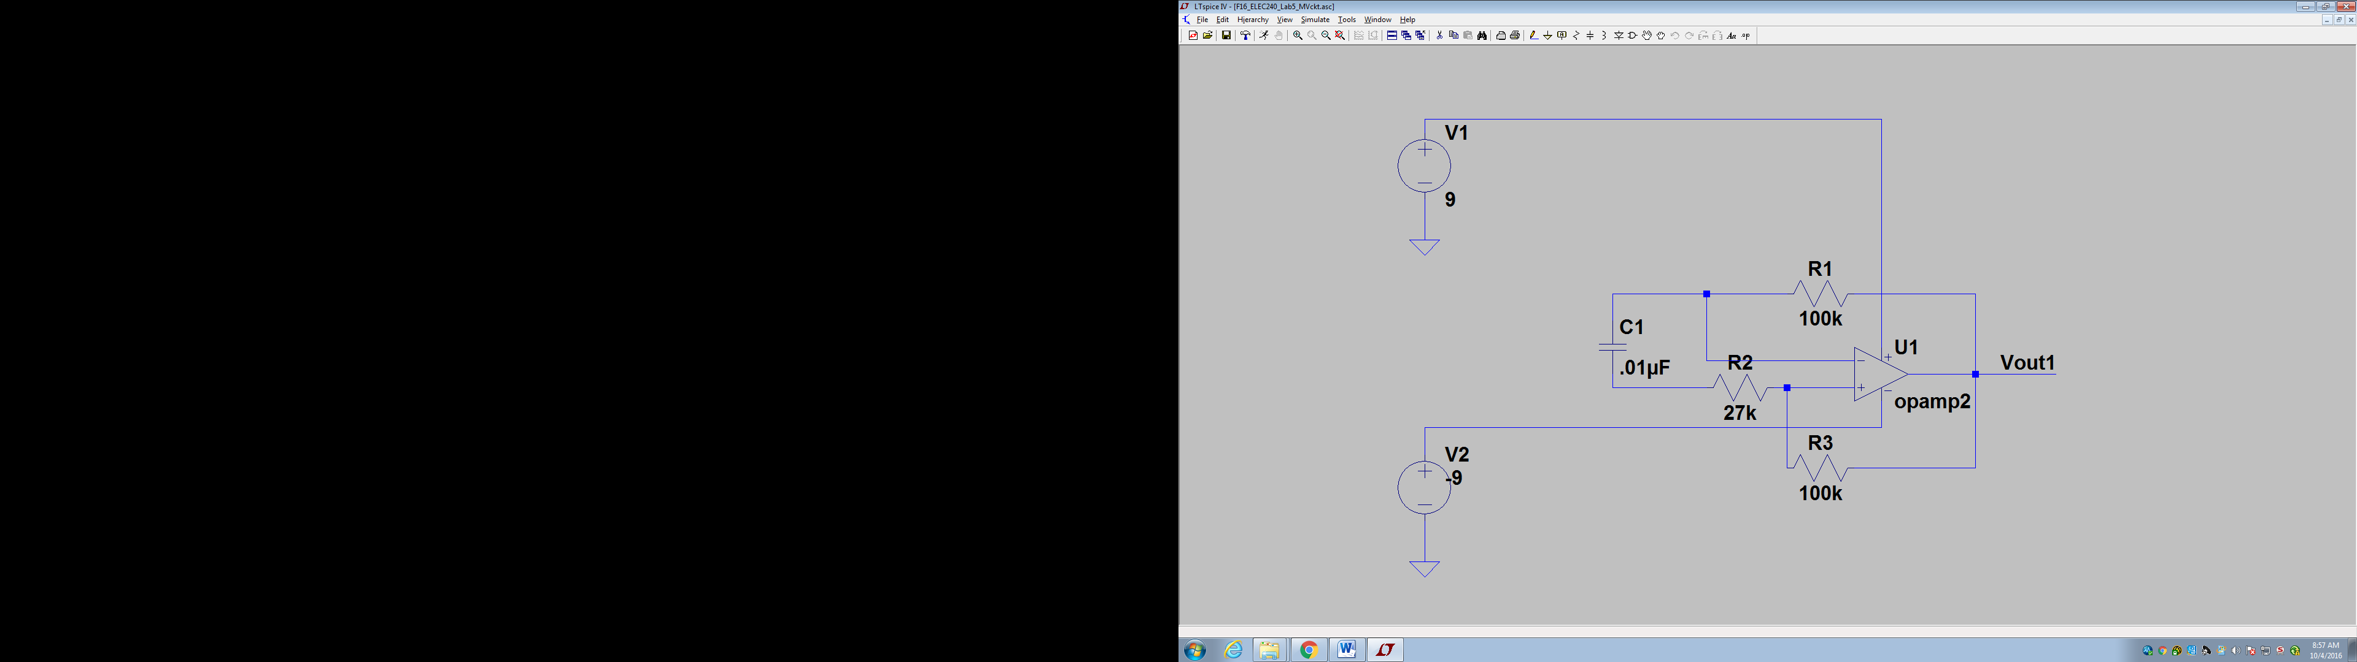
* **Is the output as expected? Provide a screenshot in your report.**
* **What is the frequency of oscillation?** 
  + The frequency should be equal to f=1/(2.2*R1*C1). Is this what you measure?
* **Does the frequency change as expected when R1 is changed?**
* Cascade an integrator circuit to the output as shown below:  
  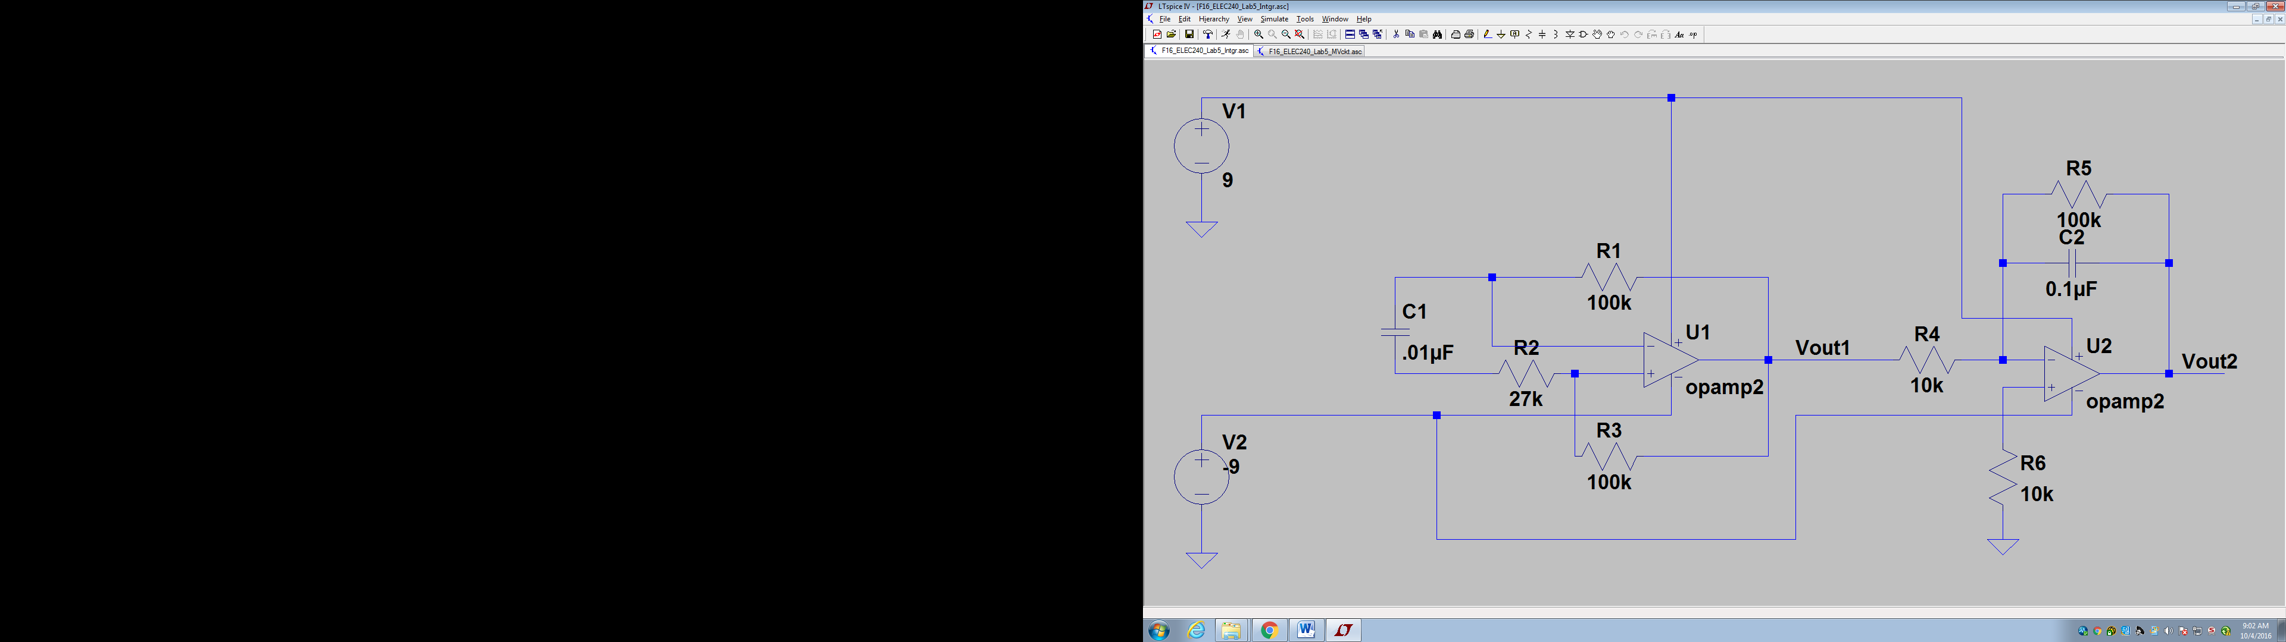
* **Is the integrator working as expected? Explain and provide a screenshot.**
* Measure the DC offset of Vout2.
  + *Note: DC offset is the average voltage of your waveform.*
* Eliminate the DC offset by placing a DC blocking capacitor (any capacitor between 0.1uF and 1uF) in between the RC relaxation oscillator and integrator. **Provide a screenshot.**
* Now add on to your circuit so that it also generates a sinusoid. **Provide a screenshot.**
* Build a gain stage to your circuit to modulate the amplitude of your sinusoidal output.