ELEC 243: Electronic Measurement Systems
Generic Lab Report Template
First A. Author and Second B. Author

Summary
Provide a summary of what was accomplished and how it fits into the grand plan. What did you learn? What was the most surprising or unexpected result? Research shows that reflecting on your experience and work, thinking about your thinking, helps solidify your learning and makes it easier to recall what you have learned.
Each laboratory will have an associated Lab Report Template. The purpose of the report is to:
- Verify that you actually did the lab.
- Demonstrate and document what you got out of the lab.
- Strengthen your learning associated with the goals of the lab.
- Provide information for improvement of the lab, and for new labs.
While it is not required, if you use the template Word file for creating your lab report, it will have the proper organization with the necessary styles predefined, and will be easier to grade. Easier to grade usually means a better grade. In any case, use a format that is similar to this and follow the guidelines below. If you need to include diagrams, graphs, or tables that are difficult to incorporate electronically, you may use a separate page or glue or tape them in place. Remember to add author information in the footer on page 2, and to delete the included instructions.

Data & Analysis
This section presents the data you collected in lab and the answers to the questions posed. In addition, the report template may include additional questions or request particular conclusions or reflections on the laboratory activities.
The data may be in the form of a table or a graph. Explain briefly what the data are, what they mean, and relevant details of how the data were acquired. Remark on whether the data were what you expected and discuss any significant discrepancies. Don't just say: "We did A, B, and C, and Ohm's Law works," tie it all together. Think of yourself as a Pulitzer prize winning journalist: you've gathered the news (doing the lab), now you're telling your readers what it means: "A, B, and C represent different techniques for measuring circuit variables, each having a different range of applicability:.... Ohm's law is handy if you're stranded on a desert island without an ammeter." Be concise; there is no need to repeat the lab instructions in the report. A sketch or circuit diagram is a compact way to provide information. If you do extra experiments or make additional measurements, be sure to include them with an explanation.
Fig. 1 is an example of a graph of measured data; note that “Fig.” is always abbreviated, even if it starts a sentence. Comments on the precision and accuracy of the data are appropriate, but you don’t need a full-blown error analysis unless requested. A figure should be located closely after the first reference to it but it is acceptable (although not as readable) to put all figures and tables at the end of the report. It is easier to use centered figures (and tables) in-line with the text rather than trying to wrap text around them.
Figure axes are often a source of confusion. Do not label axes only with units; use words rather than symbols, and put units in parentheses. For example, in Fig. 1, do not write just “E (nJ)” or “cm.” Multipliers can be especially confusing. Write the true units, “Plasma Length (cm)” or “Plasma Length (m)”. Do not write “Plasma Length (m) ÷ 100” because the reader would not know whether an axis mark labeled “16” meant 1600 m or 0.16 m. The same cautions apply to table columns.
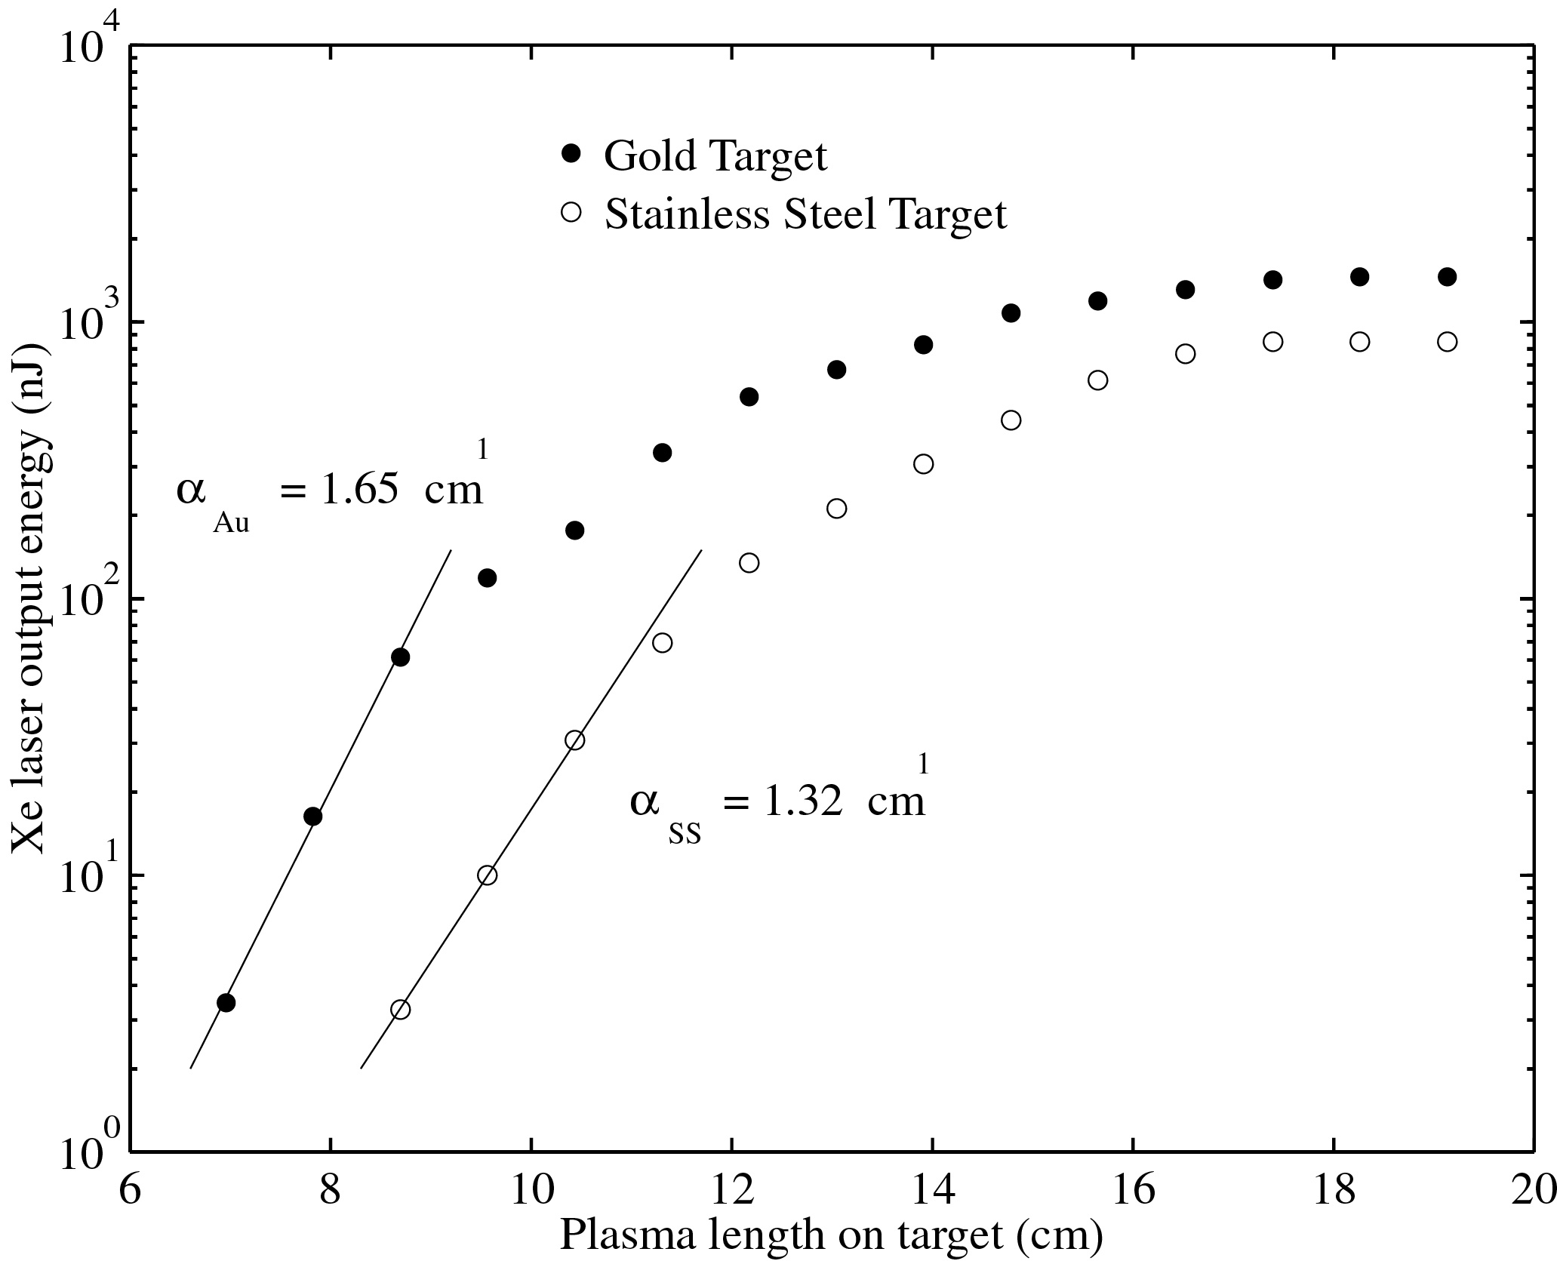

Fig. 1: It is good practice to explain the significance of the figure in the caption. “Fig.”, the figure number and the colon are in bold face. The colon is followed by a tab; the text will wrap appropriately. A diagram is also a “figure,” and uses the same style, caption, and sequential numbering.
Tables are numbered in a separate series using Roman numerals. See the example Table I. Do not abbreviate “Table” in the text or in the table title, which goes at the top. Explanatory information goes in the table caption at the bottom. Both the title and the caption are contained in a row of the table with merged column cells.
In published journals, the font in figures, tables, and references is often smaller than the main text. You may use smaller fonts, but none smaller than 10 point. The primary consideration is legibility; we are not concerned with saving space to minimize page charges. Plus, the resolution of common laser or ink jet printers does not approach that of commercial typesetting and printing, where 8 or 6 point type is still quite readable (with glasses, in my case).

Table I.
At My Institution We Need Better Ways, Besides Publications,
to Evaluate the Scholarly Performance of the Faculty
Type of Institution of Respondent | Agree | Neutral | Disagree
All Respondents | 68% | 19% | 13%
Research a | 69 | 12 | 19
Doctorate-Granting | 77 | 10 | 14
Comprehensive | 80 | 11 | 10
Liberal Arts | 69 | 16 | 15
Two-Year | 55 | 33 | 12
Source: The Carnegie Foundation for the Advancement of Teaching, 1989 National Survey of Faculty.
Vertical lines are optional in tables but generally add clutter. Statements that refer to the entire table do not need footnote letters.
a Rice University is classified as a Research I Institution.

Questions The instructions also have a sequence of numbered questions interspersed with the steps of the experiments, and you should answer these in the Data section. You may intersperse question answers with data if that makes sense. The questions don't always have a unique correct answer; sometimes they ask for your evaluation or comments. In either case, give some indication of why you chose the answer you did.

Feedback
This section gives you an opportunity to give us feedback on the lab. Provide any suggestions and comments you think will help us improve the laboratory.

